create database workers;
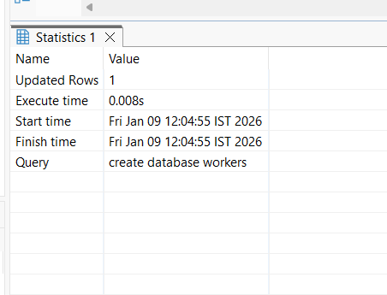

use workers;
create table employee(
emp_id int auto_increment primary key,
name varchar(250),
department varchar(250),
salary int);
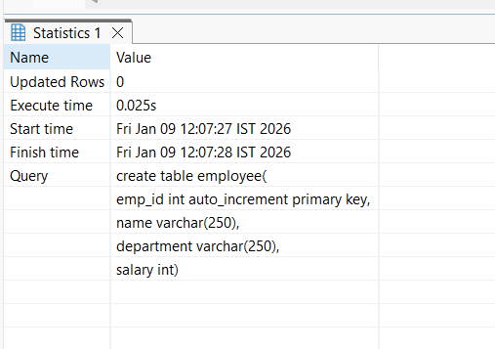

use workers;
insert into employee( name , department, salary)
values ('Fayaz', 'IT', 40000),
('Elango', 'IT', 40000),
('Viji', 'IT', 40000),
('Ajay', 'Finance', 70000),
('Ganesh', 'Finance', 70000),
('Oliver', 'Finance', 70000),
('Indra', 'Support', 50000),
('Arjun', 'Support', 50000),
('Suresh', 'HR', 30000),
('Raam', 'HR', 30000);
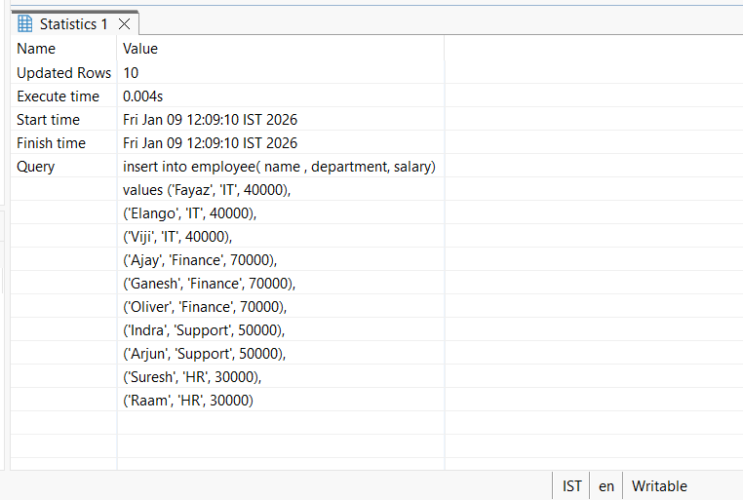

use workers;
select * from employee;
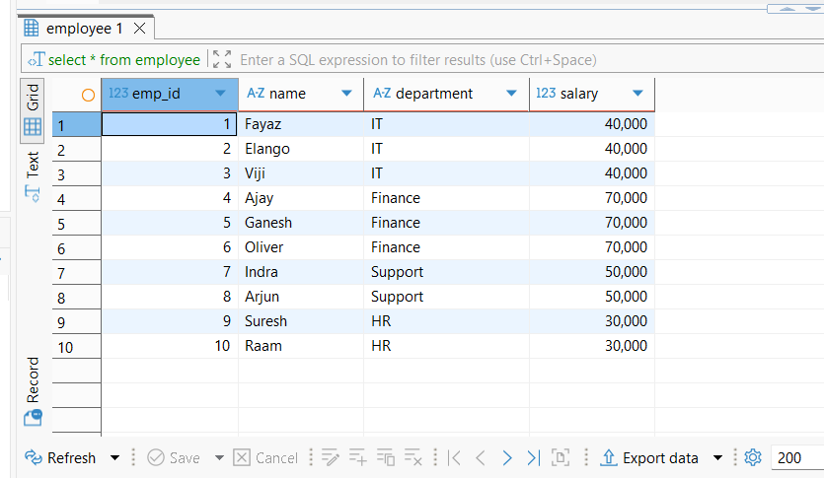

- Find employees who are NOT in IT department AND whose salary is NOT between 30000 and 50000.
use workers;
SELECT * FROM employee WHERE not department = 'IT' AND salary NOT BETWEEN 30000 AND 50000;
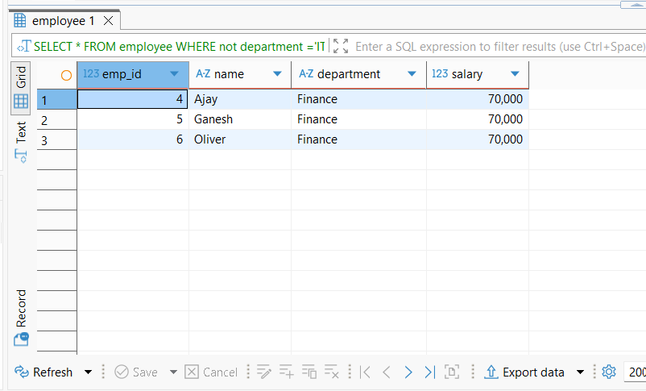
- Show employees whose name has exactly 4 letters.
SELECT * FROM employee WHERE LENGTH(name) = 4;
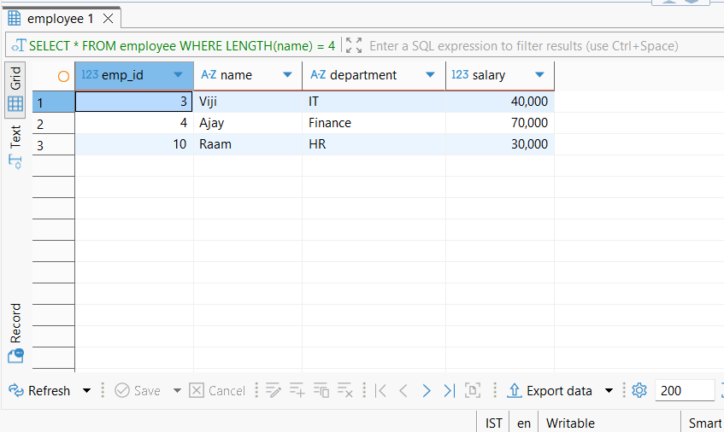

- Find the average salary of employees whose names end with ‘a’ OR department is HR.
SELECT AVG(salary) AS average_salary FROM employee WHERE name LIKE '%a'
OR department = 'HR';
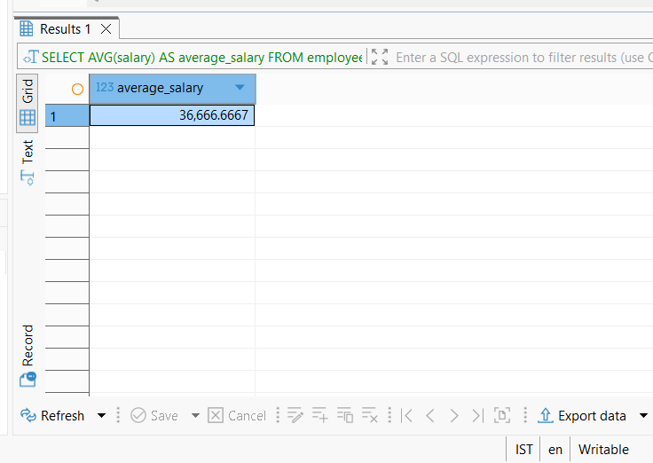

- Find total salary of employees who are NOT in Finance AND whose salary is either 40000, 50000, or 70000.

SELECT SUM(salary) AS total_salary FROM employee WHERE not department = 'Finance' AND salary IN (40000, 50000, 70000);
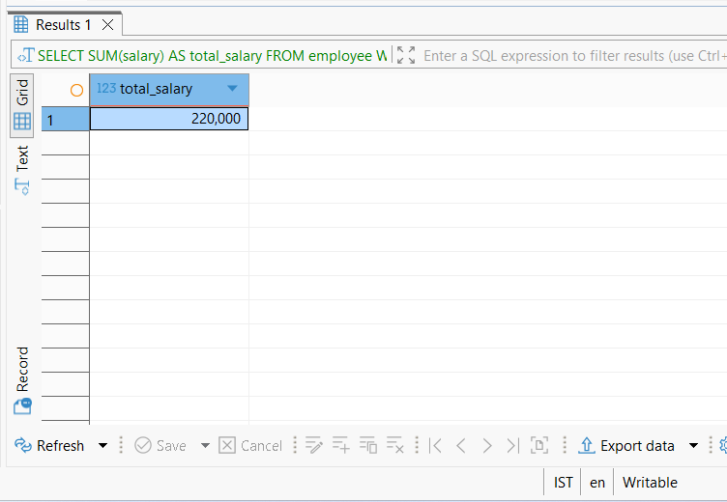

- Show employees whose name starts with a vowel (A, E, I, O, U) AND salary greater than 40000.
SELECT * FROM employee WHERE name REGEXP '^[AEIOU]' AND salary > 40000;
